
The ASEAN Economic Integration Programme (EIP) is a UK-supported initiative designed to reduce development barriers across ASEAN Member States (AMS) and foster inclusive economic growth that benefits the poorest. The EIP contributes to poverty reduction by promoting inclusion, empowering women, and supporting micro, small, and medium enterprises in the region. The programme focuses on three key areas: 1) supporting regulatory reforms to facilitate trade and economic activity; 2) promoting open trade to address barriers to trade between ASEAN member states and to enhance global trade, including with the UK; 3) strengthening and modernising financial services to improve access to finance for citizens and businesses across ASEAN.


Open Trade Pillar
Enabling a more integrated, efficient, and inclusive trade environment across ASEAN

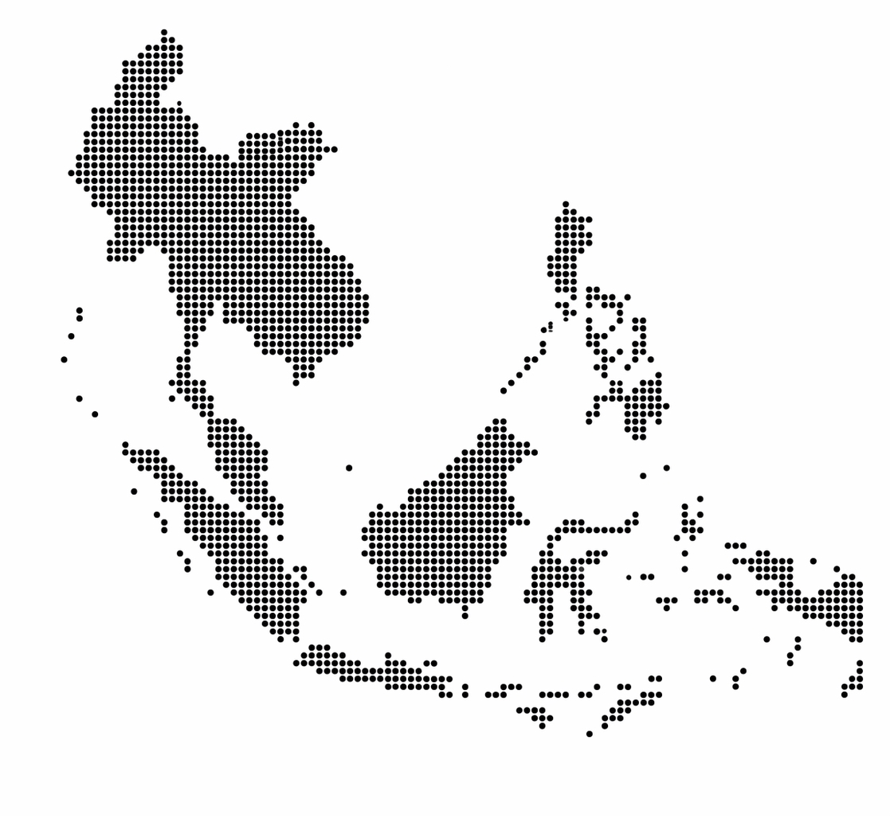

Overview

The ASEAN-UK Economic Integration Programme – Open Trade Pillar (OTp), funded by the UK Foreign, Commonwealth and Development Office (FCDO) and implemented by Cadmus, supports ASEAN’s vision of a seamless, inclusive, and sustainable economic community by reducing barriers to intra-ASEAN trade and promoting a more integrated flow of goods and services across the region. It also strengthens ASEAN’s trade links with Dialogue Partners such as the United Kingdom.

Our Objectives

The primary goal of OTp is to reduce trade barriers and promote inclusive, sustainable economic growth in the ASEAN region, through:
- Supporting the adoption of modern legal frameworks for cross-border digital trade.
- Advancing the digitalisation of trade facilitation and customs systems to reduce costs and delays.
- Identifying and addressing non-tariff barriers (NTBs) through innovative technologies.
- Ensuring MSMEs, women-led enterprises, and green sectors benefit from trade reforms.
These objectives align with ASEAN’s Digital Economy Framework Agreement (DEFA) and the ASEAN Economic Community (AEC) Post-2025 Vision, while supporting broader international trade commitments.

Our Approach: ASEAN-Led and Demand-Driven

We align with ASEAN-endorsed priorities and respond to evolving Member State needs, complementing and reinforcing regional initiatives, national strategies, and regulatory priorities.

- Demand-Driven Design: Projects are identified through ASEAN-level and Member State engagement to ensure strong ownership.
- Results-Focused Activities: Activities are selected based on a structured six-criterion framework to ensure impact and inclusivity.
- Modular & Scalable Design: Project design supports flexible adaptation, iteration, and scale.
- Concrete Deliverables: Prioritises tangible outcomes—legislation, systems upgrades, and capacity-building—over reports.
- Strategic Partnerships: OTp works closely with ASEAN Secretariat, the FCDO ASEAN Mission, ICC Digital Standards Initiative, UK Centre for Digital Trade and Innovation, and business associations to share global best practices.

Main Implementation Areas

Initiative 1: Removing Legal Barriers to Digitalise Trade Supports AMS in adopting the UNCITRAL Model Law on Electronic Transferable Records (MLETR), establishing a consistent legal foundation for digital trade across the region. Removing legal barriers enables faster, safer, and more cost-effective trade.
Initiative 2: Supporting Digitalisation of ASEAN’s Trade and Customs Ecosystem
Enhances the efficiency and interoperability of customs and trade systems through the expansion of paperless trade and the ASEAN Single Window (ASW). It also promotes the adoption of emerging technologies and supports trade-related digital transformation at both G2G and B2B levels.

Initiative 3: Addressing NTBs and NTMs through Emerging Technologies
Explores the use of big data analytics and artificial intelligence to improve the identification and mitigation of non-tariff barriers. It includes capacity building for regulators and businesses and promotes greater transparency in regulatory practices across sectors and countries.

Methodology
OTp supports both regional priorities and country-level activities, with the condition that each supported activity demonstrates relevance for at least three AMS. The implementation methodology is built around the following key principles:

- Demand-driven Design: OTp projects are identified through bottom-up engagement with AMS and top-down alignment with ASEAN and UK priorities. This ensures responsiveness to national needs and maximises political buy-in.
- Results Focus: Project selection follows a six-criterion framework that evaluates initiatives based on their potential to reduce trade barriers, alignment with ASEAN and UK priorities, ability to leverage existing skills, responsive to AMS demand, consideration of digital readiness, and promotion of inclusivity and sustainability.
- Modular and Scalable Projects: The programme design allows for self-contained project modules that can be adapted or scaled based on performance, feedback, and political context. This structure supports iterative development and ensures flexibility in responding to changing priorities or new opportunities.
- Concrete Deliverables: OTp prioritises activities that deliver practical outcomes—such as legislation, systems upgrades, and capacity-building frameworks—rather than stand-alone reports or assessments.
- Strategic Partnerships: The programme collaborates with institutions such as the ICC Digital Standards Initiative, the UK Centre for Digital Trade and Innovation, UK ASEAN Business Council and national business associations to leverage global best practices and strengthen local ownership.

Who We Work With
- Anchor Partners: ASEAN Secretariat (Trade Facilitation, Digital Economy, and Enterprise and Stakeholder Engagement Divisions), sectoral bodies (ASEAN Trade Facilitation Joint Consultative Committee, Coordinating Committee on the Implementation of the ATIGA, ASEAN Coordinating Committee for Micro, Small and Medium Enterprises), and ASEAN Member State institutions or ministries responsible for trade, customs and the digital economy.
- Strategic Knowledge Partners: ASEAN and UK centres of excellence, the International Chamber of Commerce, universities, and think tanks.
- Collaborating Partners: National trade and customs authorities, private sector associations and chambers of commerce, regulatory networks, dialogue partners, and multilateral institution

Engagement & Call to Action

The platform succeeds through strong collaboration with ASEAN institutions and our partners. We invite partners to share insights, identify opportunities for pilots or peer learning, co-create initiatives, and collaborate on knowledge and capability-building for future resilience. Together, we can deepen financial inclusion, foster innovation, and deliver shared prosperity across ASEAN.

For engagement enquiries or to explore partnership opportunities:
Claudio Dordi (Team Leader), Open Trade Pillar
Claudio.Dordi@cadmusgroup.com

